ECOSOC

Meet the chairs

Co President - Pavith Pethiyagoda

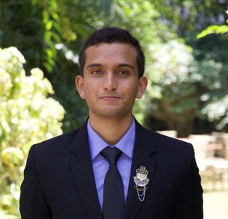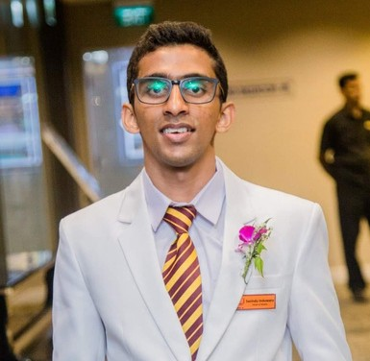Co President - Sasindu Induwara

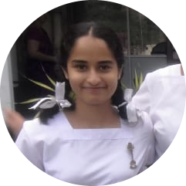Vice President - Primali Hellarawa